**Figure C.** The completeness of the HPV vaccinated individuals on the Long Island, New York State, 2012-2023. The figures are generated according to the CDC HPV vaccination guidelines.

1. The Nested Pie Chart shows the HPV Vaccination Patient Doses Schedule and Completeness Portion.

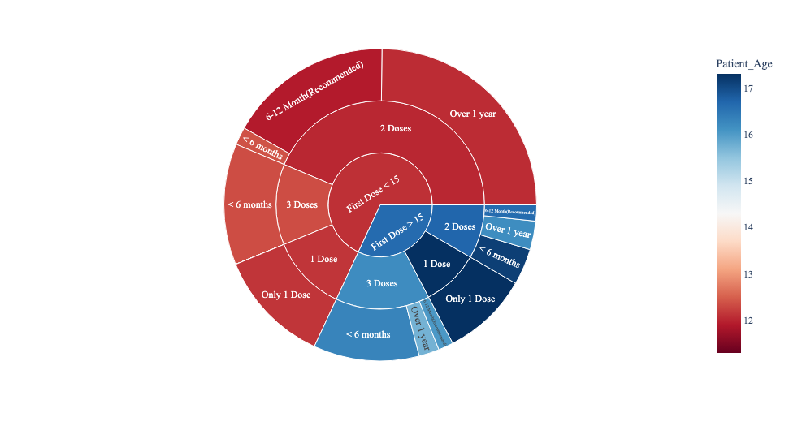

1. HPV Vaccine Series Completion by Gender
2. HPV Vaccine Series Completion by Race and Ethnicity

